Leg Curl and Extension Machine

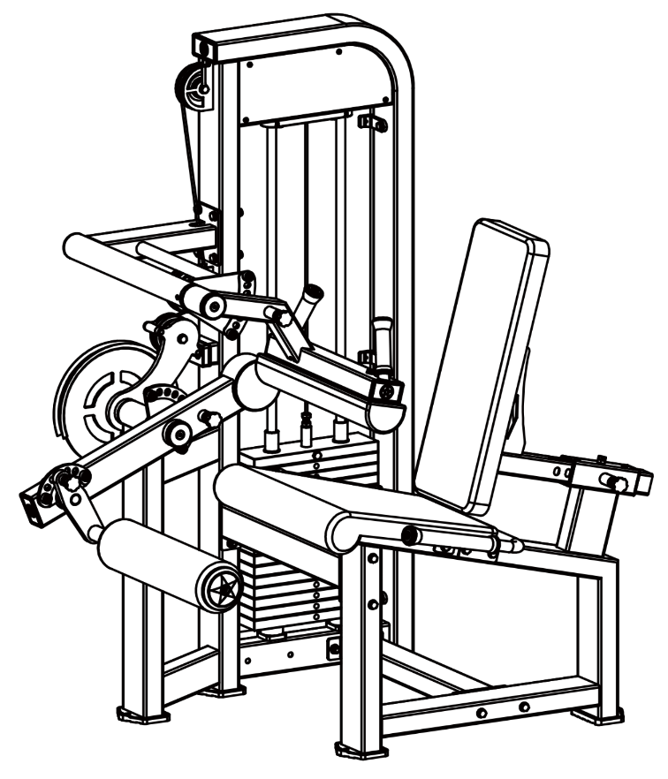

Wiring Diagram

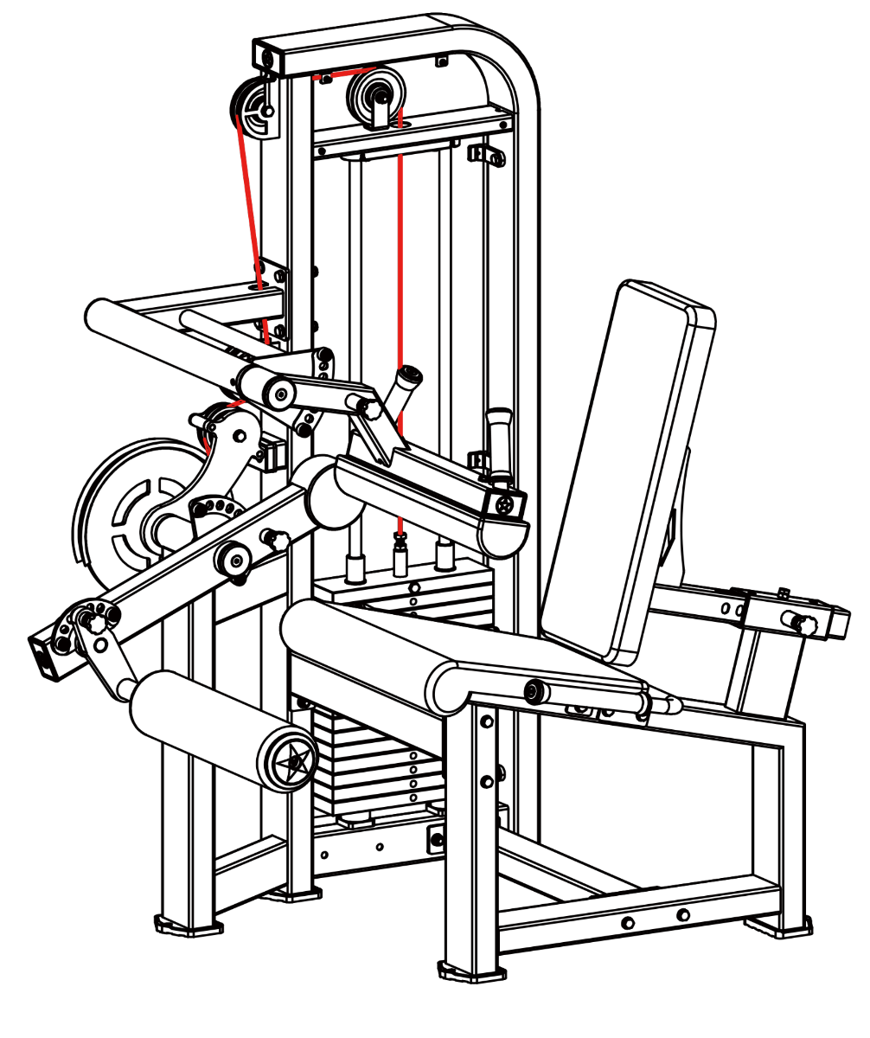

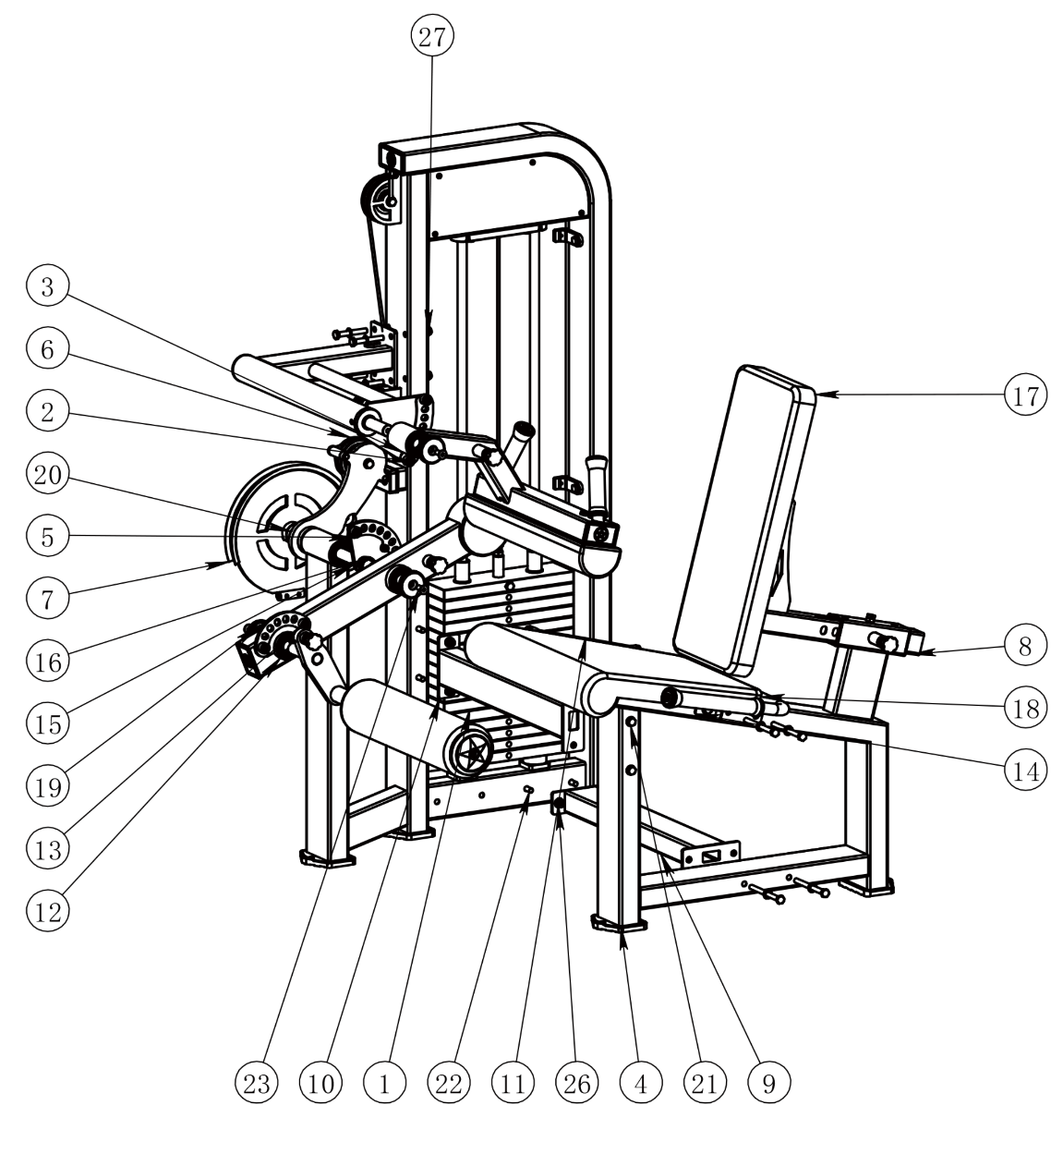
HM84C Leg Curl and Extension Machine Assembly Diagram

Item No. | Part No. | Quantity
1 | HM84C-01 Small Door Weldment | 1
2 | HM84C-02 Support Weldment | 1
3 | HM84C-03 Leg Press Weldment | 1
4 | HM84B-02 Main Frame Weldment | 1
5 | HM84B-03 Main Shaft Weldment | 1
6 | HM84B-04 Pulley Guide Weldment | 1
7 | HM84B-06 Rope Pulley Weldment | 1
8 | HM84B-07 Backrest Weldment | 1
9 | HM84B-08 Lower Connection Weldment | 1
10 | HM84B-09 Upper Connection Weldment | 1
11 | HM84B-11 Handle Weldment | 1
12 | HM84A-08 Arm Weldment | 1
13 | HM84A-09 Foam Rod Weldment | 1
14 | HM84B-2001 Seat Mounting Plate | 4
15 | 8X25 Standard Key | 1
16 | HM-5080 Powder Metallurgy Sleeve | 2
17 | HM-5066 Mid Back Cushion | 1
18 | HM-5070 Large Seat Cushion | 1
19 | HM-5043 Convex End Cap | 3
20 | HM-5042 Flat End Cap | 1
21 | External Hex Screw M10X120 Half Thread | 10
22 | External Hex Screw M10X70 | 6
23 | Internal Hex Countersunk Screw M10x25 | 4
24 | Hex Bolt M8x75 | 3
25 | Hex Bolt M8x25 | 4
26 | Lock Nut M10 | 16
27 | Flat Washer 中10 | 32
28 | Flat Washer 中8 | 7

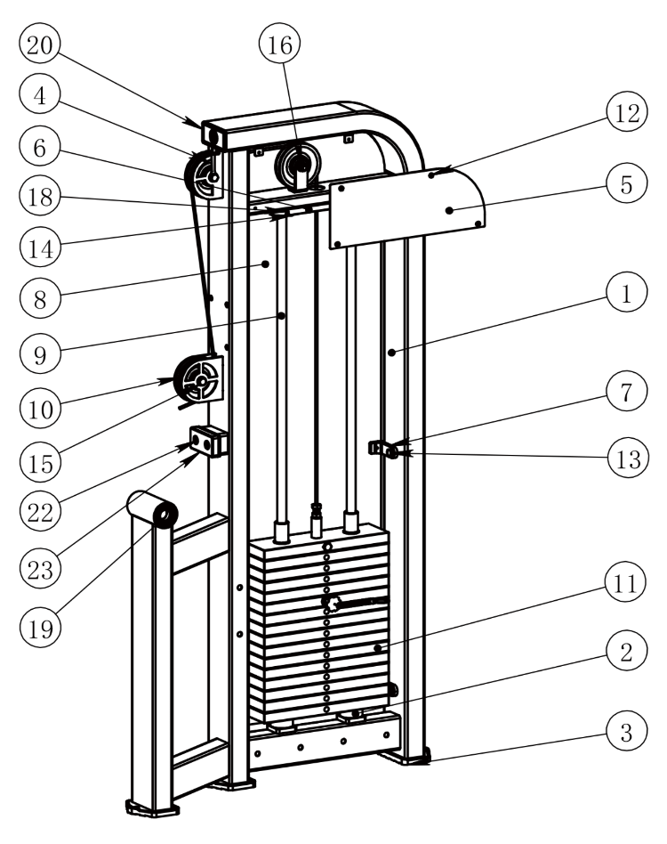
HM84C-01 Small Door Weldment

Item No. | Part No. | Quantity
1 | HM84C-01 Small Door Weldment | 1
2 | HM-5006 Weight Rubber Pad | 2
3 | HM-5007 Foot Pad | 3
4 | HM-5008 Rope Guard Plate | 2
5 | HM-5009 Upper Guard Plate | 2
6 | HM-5013 Shaft Fixing Plate | 1
7 | HM-5014 Guard Plate Bracket | 6
8 | HM-5090 Acrylic Guard Plate 1 | 1
9 | HM-5034 Small Door Guide Rod | 2
10 | HM84B Pulley 0105 | 1
11 | HM84A Weight Assembly 80KG | 1
12 | Cross Recessed Pan Head Screw M5x10 | 14
13 | External Hex Screw M10X25 | 6
14 | External Hex Screw M10X35 | 2
15 | External Hex Screw M10X50 | 3
16 | Lock Nut M10 | 3
17 | Flat Washer ①10 | 4
18 | Internal Hex Flat Head Set Screw M8x12 | 2
19 | Deep Groove Ball Bearing 6205 052x025×15 | 2
20 | HM-5010 Square Pipe Plug 50x100 | 1
21 | Hex Rivet Nut M10 | 8
22 | Internal Hex Round Head Screw M10X20 | 2
23 | HM-5084 Shock Absorber Pad | 1

第4页

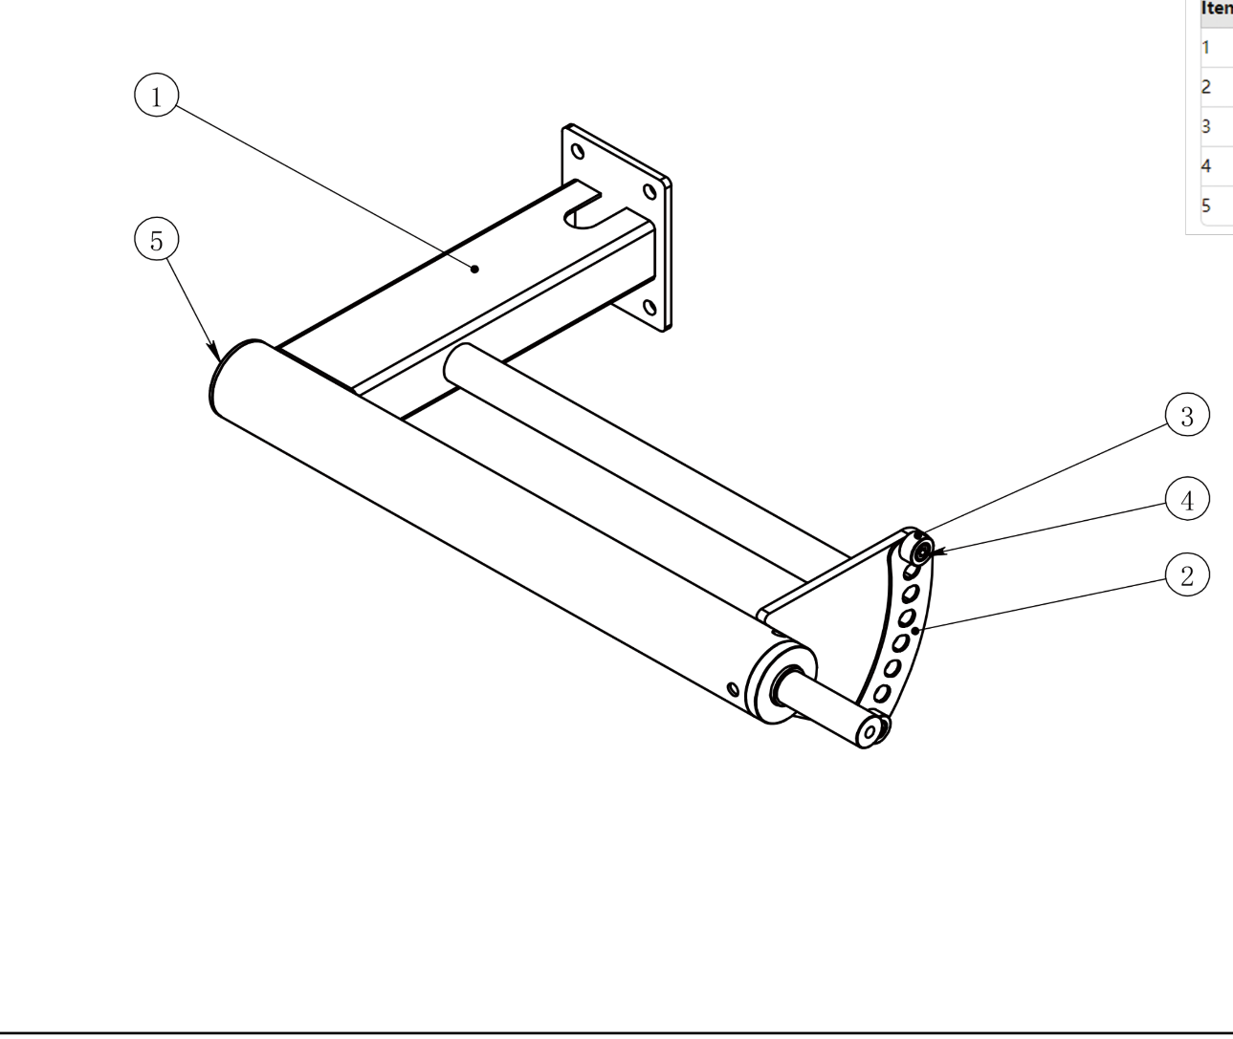
HM84C-02 Support Weldment

 | Item No. | Part No. | Quantity
 | 1 | HM84C-02 Support Weldment | 1
 | 2 | HM84C-2001 Adjustment Plate (Stainless Steel) | 1
 | 3 | HM-5037 Limiting Sleeve | 2
 | 4 | Internal Hex Socket Head Screw M8x16 | 2
 | 5 | Round Tube Plug 060 | 1

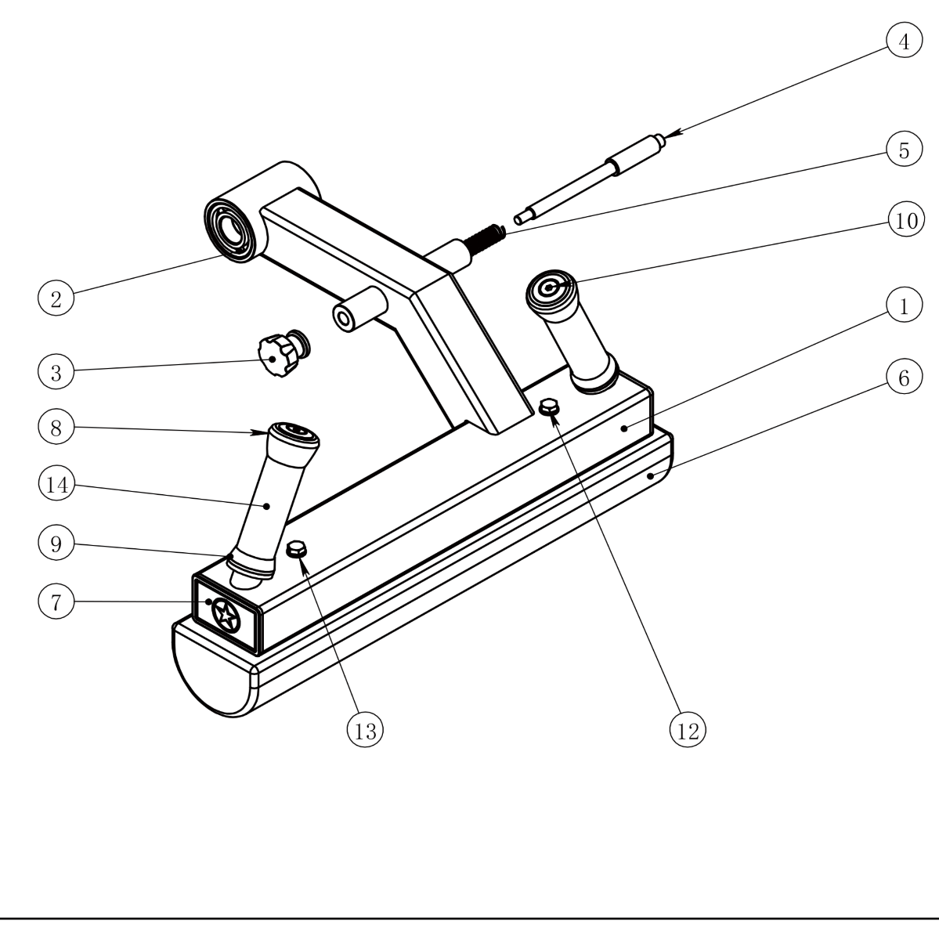
HM84C-03 Leg Press Weldment

Item No. | Part No. | Quantity
一 | HM84C-03 Leg Press Weldment | 1
2 | Deep Groove Ball Bearing 6205 052x025×15 | 2
3 | HM-5018 Pull Pin Cap | 1
4 | HM-5051 Long Pin (Galvanized) | 1
5 | HM-5017 Spring (Galvanized) | 1
6 | HM-5073 Leg Press Pad | 1
7 | HM-5011 Square Pipe Plug 50x80 | 2
8 | 5-Piece Front Set | 2
9 | 5-Piece Rear Set | 2
10 | Internal Hex Countersunk Screw M8x25 | 2
11 | HM-5057 Star Nut M8 with 020 Hole | 2
12 | Hex Bolt M8x75 | 2
13 | Flat Washer 中8 | 2
14 | HM84C Non-slip Handle | 2

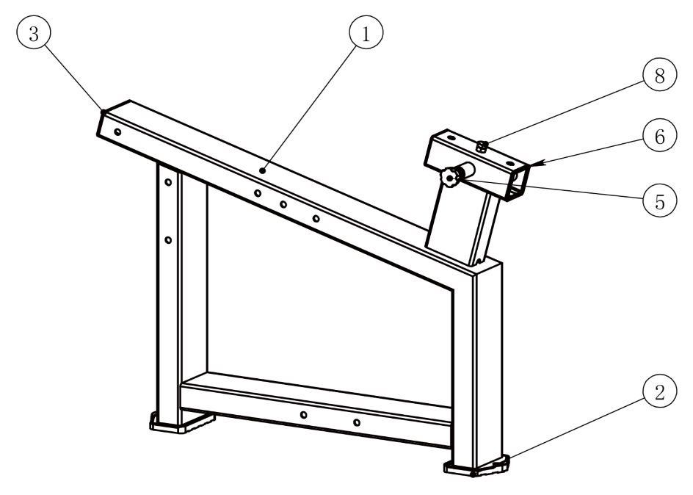
HM84B-02 Main Frame Weldment
Item No. |  | Part No. | Quantity
1 |  | HM84B-02 Main Frame Weldment | 1
2 |  | HM-5007 Foot Pad | 2
3 |  | HM-5010 Square Pipe Plug 50x100 | 1
4 |  | HM-5017 Spring (Galvanized) | 1
5 |  | HM-5018 Pull Pin Cap | 1
6 |  | HM-5053 Reset Pull Pin Shaft | 1
 | 7 | HM-5054 Reducer Sleeve 60 to 50 | 2
 | 8 | External Hex Screw M10X25 | 1

HM84B-03 Main Shaft Weldment

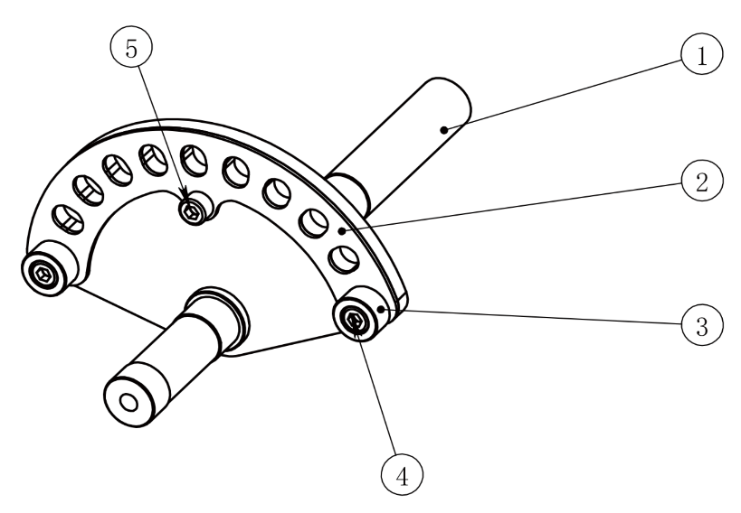

Item No. | Part No. | Quantity
1 | HM84B-03 Main Shaft Weldment | 1
2 | HM84A-2005 Adjustment Plate 5 (Stainless Steel) | 1
3 | HM-5037 Limiting Sleeve | 2
4 | Internal Hex Socket Head Screw M8x16 | 2
5 | Internal Hex Socket Head Screw M8x12 | 1

HM84B-04 Pullev Guide Weldment

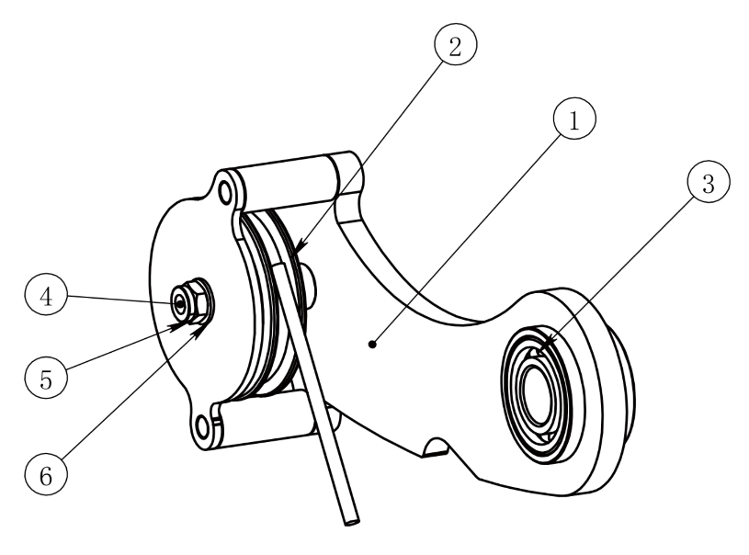

Item No. | Part No. | Quantity
1 | HM84B-04 Pulley Guide Weldment | 1
2 | HM84B 090 Pulley | 1
3 | Deep Groove Ball Bearing 6205 052x025x15 | 2
4 | External Hex Screw M10X75 | 1
5 | Lock Nut M10 | 1
6 | Flat Washer 中10 | 2

HM84B-06 Rope Pulley Weldment

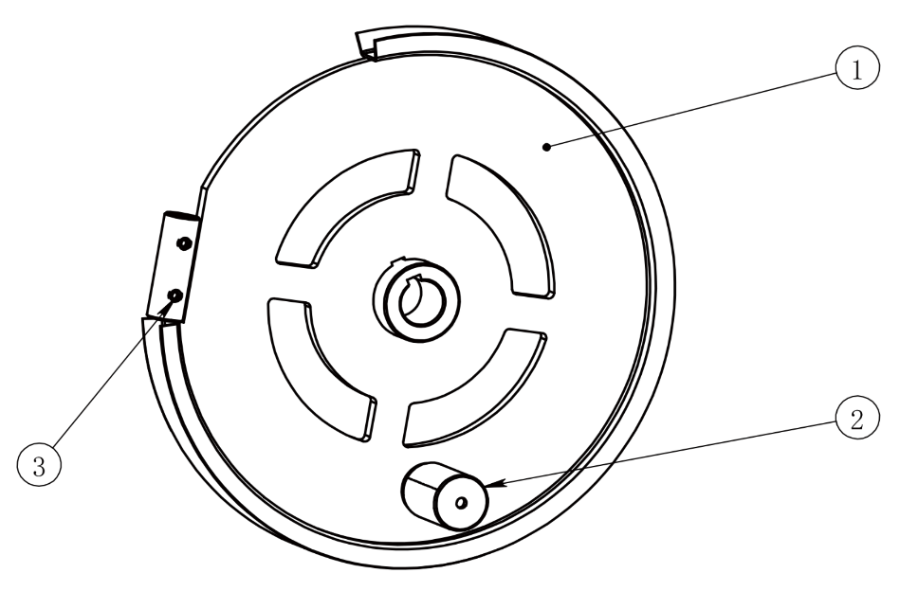

Item No. | Part No. | Quantity
1 |  | 1
1 | HM84B-06 Rope Pulley Weldment | 1
2 | F3-3003 Bumper Post | 1
3 | Internal Hex Flat Head Set Screw M8x12 | 2

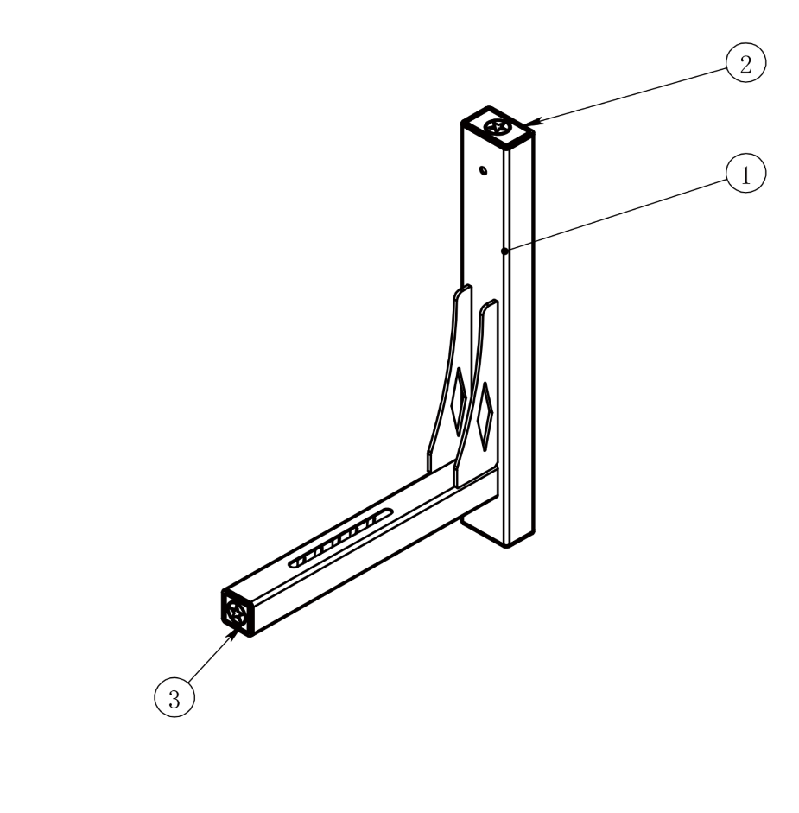
HM84B-07 Backrest Weldment

Item No. | Part No. | Quantity
1 | HM84B-07 Backrest Weldment | 1
2 | HM-5011 Square Pipe Plug 50x80 | 2
3 | HM-5012 Square Pipe Plug 50x50 | 1

HM84B-08 Lower Connection Weldment

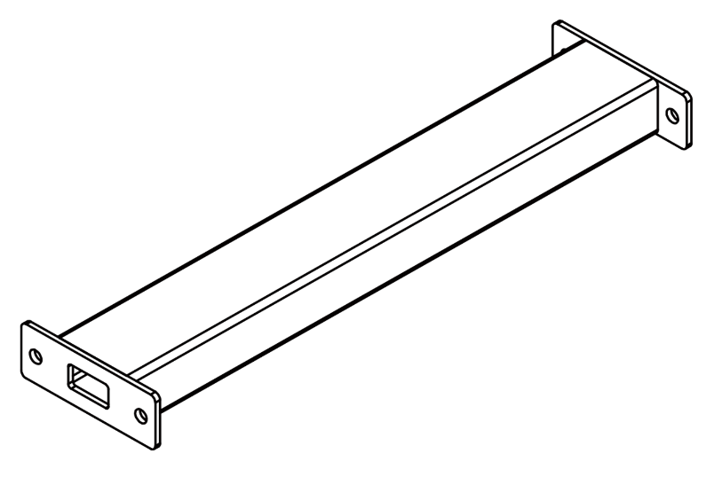

Item No. | Part No. | Quantity
 |  | 1
 | HM84B-08 Lower Connection Weldment | 1

HM84B-09 Upper Connection Weldment

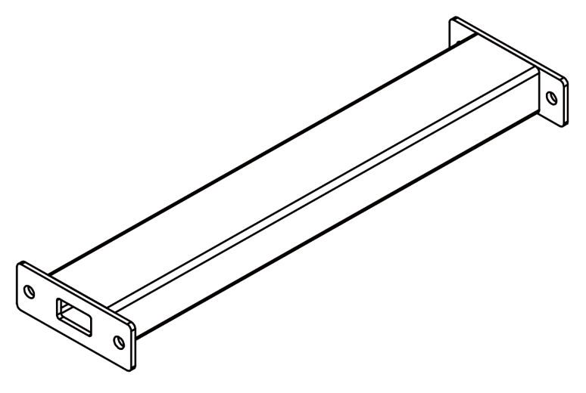

Item No. | Part No. | Quantity
1 |  | 1
1 | HM84B-09 Upper Connection Weldment | 1

HM84B-11 Handle Weldment

 | Item No. | Part No. | Quantity
 | 1 | HM84B-11 Handle Weldment | 1
 | 2 | HM84B Non-slip Handle 3 | 2
 | 3 | 5-Piece Front Set | 2
 | 4 | 5-Piece Rear Set | 2
 | 5 | Internal Hex Countersunk Screw M8x25 | 2
 | 6 | HM-5057 Star Nut M8 with 020 Hole | 2

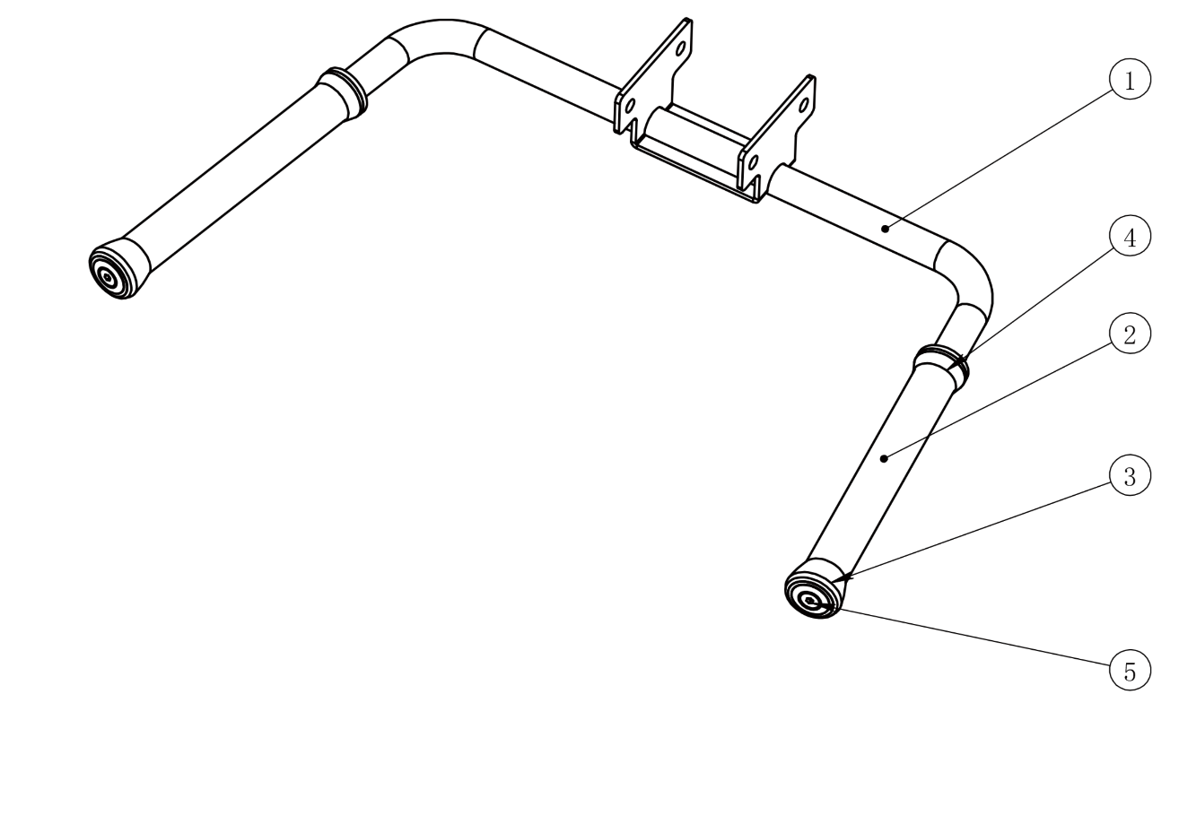

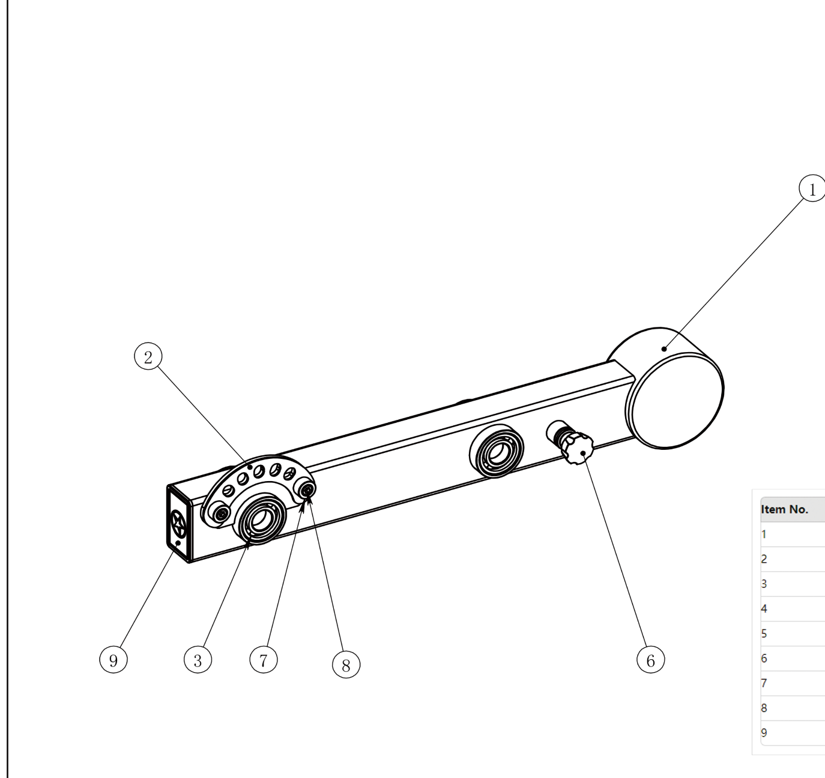
HM84A-08 Arm Weldment

 | Item No. | Part No. | Quantity
 | 1 | HM84A-08 Arm Weldment | 1
 | 2 | HM84A-2006 Adjustment Plate 6 (Stainless Steel) | 1
 | 3 | Deep Groove Ball Bearing 6205 052x025×15 | 4
 | 4 | HM-5016 Pull Pin (Galvanized) | 1
 | 5 | HM-5017 Spring(Galvanized) | 1
 | 6 | HM-5018 Pull Pin Cap | 1
 | 7 | HM-5037 Limiting Sleeve | 2
 | 8 | Internal Hex Socket Head Screw M8x12 | 2
 | 9 | HM-5011 Square Pipe Plug 50x80 | 1

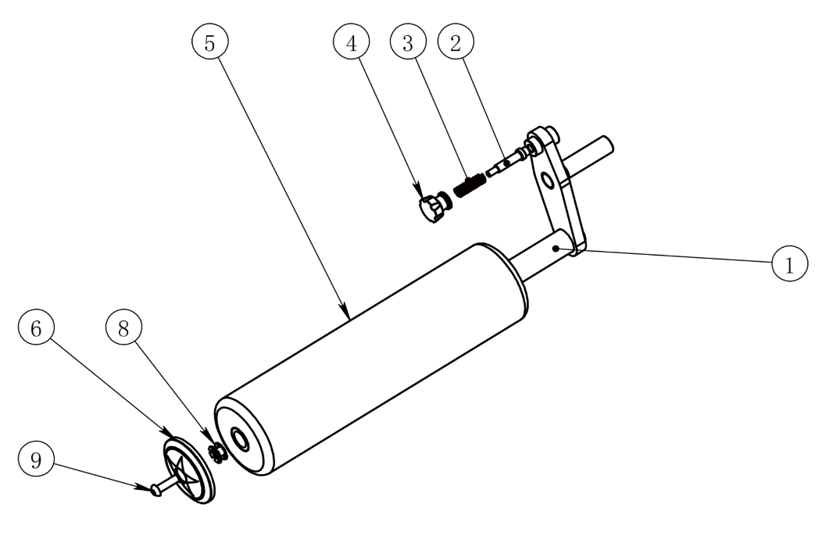
HM84A-09 Foam Rod Weldment

 | Item No. | Part No. | Quantity
 | 1 | HM84A-09 Foam Rod Weldment | 1
 | 2 | HM-5053 Reset Pull Pin Shaft | 1
 | 3 | HM-5017 Spring(Galvanized) | 1
 | 4 | HM-5018 Pull Pin Cap | 1
 | 5 | HM-5055 Large Foam | 1
 | 6 | HM-5039 Foam Outer Cover | 1
 | 7 | HM-5081 Round Tube Plug 030 | 1
 | 8 | HM-5059 Star Nut M10 with 025 Hole | 1
 | 9 | Internal Hex Round Head Screw M10X35 | 1

